LAUNCHING PLACE PRIMARY SCHOOL

STUDENT ENGAGEMENT, WELLBEING AND INCLUSION
POLICY 2020

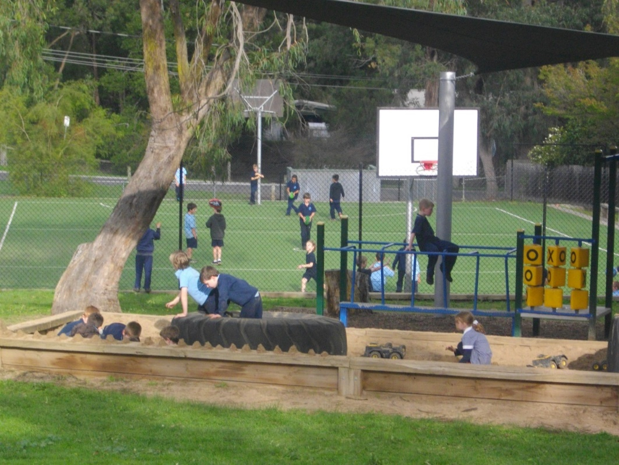
This policy reflects the DET Student Engagement and Inclusion Guidance and was produced in consultation with the school community November 2019

Principal: Narelle Messerle
School Council President: Gemma Wynd
Table of Contents

- School Profile 3
- School Values, Philosophy and Vision 3
- Guiding Principles 4
- Engagement Strategies 5
- Identifying Students in Need of Extra Support 5
- Behaviour Expectations 5
- School Actions 5
- Engaging with Families 6
- Evaluation 7
- Appendices and Related Policies 8
Appendix 1: Statement of Rights and Responsibilities 9
Appendix 2: Student Engagement Strategies 10
Appendix 3: Behaviour Expectations 11
Appendix 4: Staged Response to Behaviour Issues 13
Appendix 5: Process for Responding to Breaches of Behaviour Expectations 15
- School Profile
Launching Place Primary School offers high quality differentiated learning programs in all curriculum areas, with a strong commitment to continuous improvement and achieving excellence.
Our students have the opportunity for the best possible learning outcomes within a comprehensive, whole school curriculum. Our pedagogical focus is to develop students who are engaged, curious and who have the skills and knowledge to approach all tasks with confidence. Specialist and enrichment programs further support the school’s broad curriculum to enhance student’s talents, interests and desire to attempt new learning opportunities.
We believe all students will learn and grow in confidence as a result of becoming motivated, self-extending, independent, life-long learners; achieving mastery of the curriculum; acquiring decision making, problem solving and critical thinking skills, as well as working together effectively as part of a team and school community.
Parental support in students' education and the maintenance of school facilities is a feature of the school. A supportive School Council works cohesively to help the school deliver quality learning opportunities for all students and positively embrace initiatives which will impact on education in the future.
- School philosophy, mission, values and vision
Our school is committed to providing a safe, secure and stimulating learning environment for all students. Students can reach their full educational potential only when they are happy, healthy and safe, and when there is a positive school culture to engage and support them in their learning. Our school acknowledges that student wellbeing and student learning outcomes are inextricably linked.
Our school is also committed to preventing and addressing bullying, including cyberbullying.
Our Philosophy: Every member of the school community has a right to fully participate in an educational environment that is safe, supportive and inclusive. We aim to develop enthusiastic learners who always do their best and strive for excellence. We have adopted the School Wide Positive Behaviours mission statement of Be Safe, Be Respectful and Be a Learner.

Our Values:
Respect – Caring about ourselves, others and the environment around us
Responsibility – Being accountable for ourselves, to others and the world we live in
Resilience – Adapting and coping with everyday life by: taking risks, being independent and thinking positively
Collaboration – Working together effectively as part of a team
Excellence – High expectations are set to ensure the achievement of individual and team goals.
Our Vision:
Launching Place Primary School is committed to providing an education that prepares students to be successful, resilient and innovative learners within a rapidly changing world. Our focus is on developing a shared vision of the future and to develop a pedagogy and culture of personalised learning utilising inquiry and collaborative teaching that puts the child at the centre of the learning program.
A statement about the rights and responsibilities of all students and school staff is included at Appendix 1.
- Guiding principles
- The school will collaboratively develop and implement a fair and respectful whole-school engagement and behaviour management approach.
- The school’s curriculum will include pro-social values and behaviour to enable students to acquire knowledge and skills, value diversity and build a culture of learning, community and engagement.
- The school will promote active student participation and provide students with a sense of ownership of their environment.
- The school will support families to engage in their child’s learning.
- The school promotes active ‘student participation’ as an avenue for improving student outcomes and facilitating school change.
- The school will establish social/emotional and educational support for vulnerable students and monitor and evaluate progress.
- The school will have processes in place to identify and respond to individual students who require additional assistance and support.
- The school follows procedures in line with the Child Safe Standards.
- The school will build strong links with the local community to gain access to an extended network of community members, professionals and educators.

- Engagement Strategies
To realise our vision, our school has in place a range of strategies to promote engagement, positive behaviour and respectful relationships for all students in the school. We recognise that some students, as a group or as individuals may need extra social, emotional or educational support to flourish at school; we will put in place strategies to identify these students and provide them with the support they need.
Launching Place Primary School works collaboratively with students and parents/ carers to establish fair and respectful behaviour policies and practices, based on the school’s values, expected social competencies and positive peer relationships. There are also intervention strategies in place to address inappropriate behaviours which can negatively impact on the learning environment of the self and others.
The universal (whole-school), targeted (group-specific) and individual engagement strategies used in our school are outlined in Appendix 2.
- Identifying students in need of extra support
Our school will utilise the following information and tools to identify students in need of extra support using the following strategies:
- Personal information gathered upon enrolment
- Attendance rates
- Academic performance and growth, particularly in literacy and numeracy assessments
- Behaviour observed by classroom teachers
- Engagement with student families
- School Entry Health Questionnaire

- Behaviour expectations
Shared behaviour expectations for students, parents/carers and school staff are detailed at Appendix 3.
- School actions
Responding to challenging behaviour
Where a student acts in breach of the behaviour standards of our school community, we will institute a staged response, as outlined in the Department of Education and Training Student Engagement and Inclusion Guidance (see Appendix 4).

Discipline
Disciplinary measures may be used as part of a staged response to challenging behaviour in combination with other engagement and support strategies to address the range of factors that may have contributed to the student's behaviour.
Disciplinary measures that may be applied include:
- Restorative approach (e.g. repairing damage caused)
- Behaviour club (recess and lunch times)
- Withdrawal of privileges
- Withdrawal from class activities for a specified period. Where appropriate, parents/carers will be informed of such withdrawals
- Suspension (in-school and out of school)
- Expulsion
Discipline will be applied in a way that is proportionate to the behaviour and upholds procedural fairness
Corporal Punishment is prohibited in all Victorian schools. Corporal punishment must NOT be used at the school under any circumstances.
Suspension and expulsion are measures of last resort and may only be applied when the grounds for suspension and expulsion set out in the Engagement and Inclusion Guidance have been met.
Suspension and expulsion can only be approved by the principal and Launching Place Primary School will follow the processes for applying these disciplinary measures set out in the Student Engagement and Inclusion Guidance.
Information on grounds and processes for suspension and expulsion that our school will follow are available here:
http://www.education.vic.gov.au/school/principals/spag/participation/Pages/engagement.aspx

- Engaging with families
Launching Place Primary School values parent / carer input into its operations and curriculum offerings and seeks feedback through the Parent Opinion survey, and from parent representatives on School Council. The School Council provides assistance and encouragement to the Parents’ and Friends’ Association in our efforts to build a sense of community.
The school will support families to engage in their child’s learning and build their capacity as active learners. It provides an environment that welcomes all parents/carers and is responsive to them as partners in learning.
The school will create successful partnerships with parents/carers and families by:
- ensuring all parents/carers are aware of the school’s Student Engagement, Wellbeing and Inclusion Policy and the school’s Code of Conduct
- conducting effective school-to-home and home-to-school communications
- providing volunteer opportunities to enable parents/carers and students to contribute
- involving families with homework and other curriculum-related activities
- involving families as participants in school decision-making
- coordinating resources and services from the community for families, students and the school
- involving families in Student Support Groups
Parent’s responsibilities for supporting their child’s attendance and engagement are outlined at Appendix 3. Furthermore, parents are expected to act in a respectful and constructive manner when dealing with our school.
- Evaluation
Data collection and analysis
Data will be collected regarding frequency and types of wellbeing issues, so as to measure the success or otherwise of school-based strategies and approaches.
Some of sources of data used are:
- the Attitudes to School Survey data
- school level report data
- parent survey data
- data from case management work with students
- data extracted from software such as CASES21 or SOCS
Review of this policy
This policy will be reviewed annually or more often if necessary due to changes in regulations or circumstances.

- Appendices and Related Policies
Appendix 1: Statement of Rights and Responsibilities
Appendix 2: Student Engagement Strategies
Appendix 3: Behaviour expectations
Appendix 4: Staged response to behaviour issues
Appendix 5: Process for responding to breaches of Behaviour Expectations
Related Policies:
Child Safe Policy
Bullying and Harassment Policy
Code of Conduct Policy
eSmart Policy
Attendance policy

This policy is informed by the Department of Education and Training Student Engagement and inclusion Guidance available at
http://www.education.vic.gov.au/school/teachers/studentmanagement/Pages/studentengagementguidance.aspx

Appendix 1
STATEMENT OF RIGHTS AND RESPONSIBILITIES
At Launching Place Primary School all members of our school community will participate in an educational environment that is consistent with the Charter of Human Rights and Responsibilities Act (2006).
This charter affirms that all people are born free and equal in dignity and rights. While the charter demands equity for all, it also emphasizes the value of difference. The charter requires that public authorities, including government schools and their employees act compatibly with human rights and consider them when making decisions and delivering services. The four basic principles are Freedom, Respect, Equity and Dignity.
It is the right of all members of the school community to experience a safe and supportive learning and teaching environment. Staff, students and parents/ carers have a right to be treated with respect, and enjoy an environment free from bullying (including cyber bullying), harassment, violence, discrimination or intimidation.
Teachers also have the rights to be informed, within privacy requirements, about matters relating to students that may impact on the teaching and learning for that student.
Students have a responsibility to contribute positively to the educational experience for themselves and other students, to participate fully in the school’s educational program, and to ensure that their behaviours demonstrate respect for themselves, their peers, their teachers and all other members of the school community.
Parents/ carers have a responsibility to take an active interest in their child’s educational progress, model and reinforce positive behaviours and ensure their child’s regular attendance. They have a responsibility to support the school in maintaining a safe and respectful learning environment for all students, and engage in regular and constructive communication with school staff regarding their child’s learning.
Teachers have a responsibility to demonstrate the standards set by the Victorian Institute of Teaching. That is, to know how students learn and how to teach them effectively, know the content they teach, know their students, plan and assess for effective learning, create and maintain safe and challenging learning environments, and use a range of strategies to engage students in effective learning. Teachers also have a responsibility to fairly, reasonably and consistently implement the Student Engagement, Wellbeing and Inclusion Policy, with reference to the Child Safe Standards.
All members have an obligation to ensure school property is appropriately used and maintained.
All staff, volunteers and associated members of Launching Place Primary School are required to observe Child Safe principles and expectations for appropriate behaviour towards and in the company of children.
All personnel of Launching Place Primary School are responsible for supporting the safety, participation, wellbeing and empowerment of children, as outlined in the Code of Conduct policy.

Appendix 2
Universal strategies | Targeted strategies | Individual strategies
- Our teachers will adopt a range of teaching and assessment approaches to effectively respond to the diverse learning styles, strengths and needs of our students.  - Our school will develop behavioural expectations for all members of the school community in consultation with students, staff and parents/carers, and these will be taught to all students and shared with their families.  - Our school will regularly acknowledge examples of positive behaviour and student achievement, both informally in classroom settings and more formally in events such as assemblies and via communications to parents.  - All students will have the opportunity to participate in a social and emotional learning curriculum program.  - Students will have the opportunity to contribute to, and provide feedback on, decisions about school operations both through the Junior School Council and other more informal mechanisms. | - Welfare team will undertake health promotion and social skill development in response to needs identified by classroom teachers or other school staff during the school year.  - Relevant teaching staff will apply a trauma-informed approach (using  http://www.copmi.net.au/find-resources/resource-library/item/calmer-classrooms-a-guide-to-working-with-traumatised-children  and similar resources) to working with students who have experience trauma, such as students who are in out of home-care. | Strategies to support attendance and engagement of individual students include:  - Meet with the student and their parent/carer to talk about how best to help the student engage with school.  - Establish a Student Support Group.  - Seek extra resources under the Program for Students with Disabilities for eligible students.  - Develop a Behaviour Support Plan and/or Individual Learning Plan.  - Consider if any environmental changes need to be made, for example changing the classroom set up.  - Refer to internal support services e.g. Student Welfare Team or Student Support Services.  - Refer to external support services such as ChildFirst, Local Government Youth Services and Community Agencies such as CYHMS.
STUDENT ENGAGEMENT STRATEGIES

Appendix 3
SHARED BEHAVIOUR EXPECTATIONS
 | Students | Parents/Carers | Principals/Teachers & Staff
Engagement (participation in the classroom and other school activities) | Demonstrate:  - preparedness to engage in and take full advantage of the school program  - effort to do their very best  - self-discipline to ensure a cooperative learning environment and model the school values  - team work | - Promote positive outcomes by valuing the importance of education and liaising with the school on their child’s progress/needs  - Support their child in their preparedness for the school day and in the provision of a supportive home environment  - Monitor their child’s school involvement and progress and communicate with the school when necessary  - Are informed and supportive of school programs and actively participate in school events/parent groups | - The school will comply with its duty of care obligations and have a responsibility to provide an educational environment that can effectively engage all students  - The school will provide an appropriate, relevant and challenging curriculum that gives students the opportunity to have input into their learning and experience success
Attendance | All students are expected to:  - Attend and be punctual for school every day that the school is open to students  - Be prepared to participate fully in lessons  - Bring a note from their parents/carers explaining an absence/lateness | Parents/Carers are expected to:  - Ensure that their child’s enrolment details are correct  - Ensure their child attends regularly  - Advise the school as soon as possible when a child is absent  - Account for all student absences  - Keep family holidays within scheduled school holidays (where possible)  - Support their child’s learning during absences and work with the school to reintegrate students after prolonged absences | In accordance with DET procedures the school will:  - Proactively promote regular attendance  - Mark rolls accurately twice per day: 9.00am and 2.00pm  - Follow up on any unexplained absences promptly and consistently  - Identify trends via data analysis  - Report attendance data in the school’s Annual Report  - Support students whose attendance is problematic by developing ‘Return to School’ plans and working with families to implement individual strategies
Behaviour | Students are expected to:  - Model the schools core values of respect, responsibility, resilience, excellence and collaboration  - Always treat others with respect  - Never physically or verbally abuse others  - Take responsibility for their behaviour and its impact on others  - Obey all reasonable requests of staff  - Respect the rights of others to learn. No student has the right to impact on the learning of others  - Respect the property of others | Parents/Carers are expected to :  - Have high expectations of their child’s behaviour and an understanding of the schools behavioural expectations  - Communicate with the school regarding their child’s circumstances  - Cooperate with the school by assisting in the development and enforcement of strategies to address individual needs | The school will:  - Deliver an inclusive and comprehensive curriculum which promotes positive behaviours and emphasises the wellbeing of every child  - employ whole school and classroom practices to establish a climate in which appropriate behaviour is the norm for all students and focus on the implementation of preventative and early intervention strategies to deal with attendance and behavioural issues  - Consistently apply its Behavioural Policy through a shared collegiate understanding and only exclude students in extreme circumstances  - Recognise that for some students additional support may be needed in the form of staged responses and is committed to working with families to reintegrate students after exclusion

Appendix 4
STAGED RESPONSE CHECKLIST FOR STUDENT BEHAVIOUR ISSUES
Stage 1: Promoting positive behaviour and preventing behavioural issues
Suggested strategies | School actions
Define and teach school-wide expectations for all. | - Our Values will be discussed regularly in class, at assembly and in the Newsletter  - Continue to reinforce our whole school social and emotional program based around respectful relationships.  - All parents/student will be made aware of our School Code of Conduct.
Establish whole school positive behaviour programs. | - Teachers will use a Restorative Practices approach to dealing with any behaviour concerns.  - Teachers will use the same approach and use similar language throughout the school. For example; “I can see that you are upset, what has happened?” or “What could you say to the person who you have upset?”
Establish consistent school-wide processes to identify and support students at risk of disengagement from learning. | - Students at risk of disengagement can be raised with the Student Wellbeing Team.  - Meetings with the Parents can be arranged to meet the needs of the child.  - Meetings with our Chaplain/ Student Support Services Officers can be arranged to provide strategies to assist the child.

Stage 2: Responding to individual students exhibiting challenging behaviour
Suggested strategies | School actions
Assess the behaviour and its functions, influences, and triggers (include student, parents and school wellbeing staff as appropriate). | - Staff are to follow the Behaviour Management Plan established by the school.  - Ongoing behaviour concerns are to be raised with the Principal/ Assistant Principal and parents if required.
Develop Behaviour Support Plan and/or Individual Education Plan (involve parent or carer). | - SSGs will be arranged twice a year involving teachers, parents and outside agencies to discuss a Behaviour Support Plan/Individual Education Plan.  - For more information on BSP: http://www.education.vic.gov.au/about/programs/bullystoppers/Pages/teachplans.aspx
Consider if any environmental changes need to be made. | - After discussions with the Principal/ Assistant Principal, parents and/or SSSOs, changes may be required including but not limited to  - classroom setup – removal from the classroom – missing out on certain activities.
Teach replacement behaviors. | - Teachers will work closely with their own strategies and those provided by the SSSOs.  - Support will be provided by the Principal/ Assistant Principal.
Engage Student Support Services and/or community services to undertake assessments and/or provide specialist support | - Teachers and parents will be able to discuss any concerns with the Principal/ Assistant Principal.
Establish a student support group | - SSGs will occur for students identified by the school or requested from home.
Implement appropriate disciplinary measures that are proportionate to problem behaviours | - The school has a Behaviour Management Plan that establishes an appropriate response to a behaviour concern.
Consider EMR Options Capacity Building team or out-of-school behaviour management options such as Student Development Centres (if available) | - Out-of-school behaviour management would be accessed only on the suggestion of the SSSOs or parents depending upon each individual situation.

Appendix 5

PROCESS FOR RESPONDING TO BREACHES OF BEHAVIOUR EXPECTATIONS
Rules | Classroom Teacher Responsibility | Principal/ Assistant Principal
Overall behaviour  - Students must obey all reasonable requests of staff.  - Students must always treat others with respect.  - Students must respect the rights of others to learn. No student has the right to impact on the learning of others.  - Students must respect the property of others.  - Students must work to the best of their ability. | Follow Classroom/ School Rules:  - Warning  - If the student will not follow instructions or requests, they will be sent to their buddy classroom for time out.  - If behavior continues or escalates contact Principal/ Assistant Principal. Student sent to office for withdrawal.  Continued misbehaviour warrants:  - Incident Report to Principal/ Assistant Principal  - Contact with parent after consultation with Principal/ Assistant Principal | Implement a staged response:  - Speak with the student  - Think Sheet/ POOCH  - Restorative chat with affected parties  - Behaviour Management Plan established if needed  - Student Contract  - Parent contact  - Student Support Group meeting  - In-house suspension  - Recommendation to externally suspend
Attendance and punctuality  - Students must be on time to all classes.  - Students who are late must report to the Office to get a late pass.  - Students who leave school early must be signed out by a parent/ carer.  - Students absent from school must ensure reasons for the absence have been communicated with the school.  - Notification from home (ie: signed note or medical certificate) must accompany all absences.  - Students must not leave the school grounds without permission. | - Check late pass. Adjust attendance roll from Absent to Late.  - If ongoing concerns about Attendance occurs, teacher to contact Assistant Principal. | - Speak to student about lateness issues.  - Follow through with student and / or parent/guardian/carer
Uniform  - Students must adhere to the school uniform requirements.  - It is compulsory for all students to wear appropriate footwear at all times. | - Remind students of correct school uniform.  - Contact parents if ongoing concern. | - Remind students of correct school uniform.  - Contact parents if ongoing concern.
Bullying  - Students must not bully, intimidate, exclude or harass others. This includes any verbal, cyberbullying, physical or sexual conduct which is uninvited, unwelcome or offensive to a person. | - Report to Principal/ Assistant Principal | - Contact parents  - Refer to schools Acceptable Use Agreement.  - Use resources from Bullystoppers, “I’ve been called a bully” or “Students and Cyberbullying” to prompt reflection.  - Refer to our school’s Bullying Prevention Policy. Consequences may include apology, anti bullying contract, student task related to anti bullying/cyber bullying, presentation of task to year level, referral to intervention program and/or counselling.  - Some cases may warrant immediate suspension. This decision must be made by the Principal.  - Student removed from classroom and parent contacted to collect students. Following procedure in Student Engagement and Inclusion Guidance re: Immediate suspension.
Property and security  - Students are to respect all school property.  - Students must not enter staff room or offices unless supervised.  - Students must bin all rubbish.  - Students must not have chewing gum at school.  - Students must return borrowed school material on time.  - Electronic devices must not be used without permission.  - Classrooms must be left neat and tidy.  - Graffiti of any kind will not be tolerated. | - Challenge behaviours around rights and responsibilities and impose consequence e.g. clean up duties in school grounds.  - For repeated offences, refer to Principal/ Assistant principal.  - Retain any evidence of graffiti and report to Principal/ Assistant Principal. | - Challenge behaviours around rights and responsibilities and impose consequence e.g. clean up duties in school grounds.  - Parent notified. Student required to repair damage. Parent may be required to meet costs if external service needed.  - If extensive and persistent issue, organise a parent meeting to review behaviour and discuss supports and next steps.

Evaluation

This policy will be reviewed as part of the school’s three-year review cycle.

Policy: | Student Engagement, Wellbeing and Inclusion Policy
Date Approved: | November, 2019 | Person Responsible: | Principal / Education Committee
Date for Review: | November, 2020 | Date Updated on Policy Index: | December, 2019

